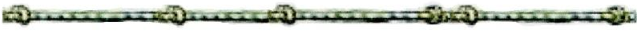

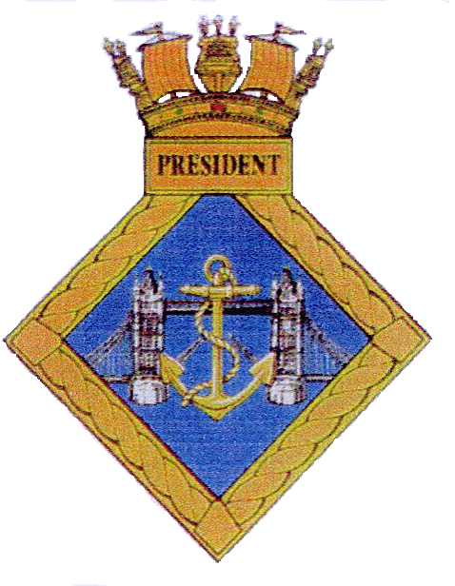
HMS President
Old Hands Association

Membership and subscription form
Surname
Forename
Full Address
Tel Number
Email address
Date of birth
Decorations/nominals
Brief Service /Reserve History
Rank/rate. Serv No.
Because our meetings take place in an active Royal Navy establishment, all applications are approved by the committee.
Once approved you will be forwarded payment details. The cost is a ‘one off’ £10 joining fee and a £5.00 Annual Subscription.
Applicant Signature (Electronic is accepted)……………………………………………………………………….
Date ………………………………………………………………………………………………………………………………..

Committee use only

